**Chapter x**

**Using NRF24L01 in communications**

**Introduction:-**

NRF24l01 is a physical device that is working in RF (radio frequency) range. Our aim here is to make it work. It has many advantages If we compare it with any wireless device advantages like ZigBee, Wi-Fi and Bluetooth (shown in **FIG.1**):-

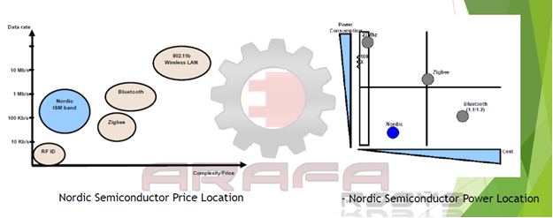

**Fig.1**

In the previous shown figure (**FIG.1),** the NRF24L01 has very low cost (around 2$), with acceptable data rate range (from 250-kbps to 2Mbps) and very low power consumption if we compared it with any wireless devices like ZigBee, Wi-Fi…etc. Beside all this advantages and features that we will talk about it later, it is used as a peripheral interface device with the SPI of the microcontroller. It is short indoor distance (if there are many barriers it will not work properly).

Our task here is to establish a serial communication between microcontroller and NRF24L01 to make wireless communication with another NRF24L01 and control the communication process of transmitting and receiving data” it is not an easy task “.

**General idea and algorithm:-**

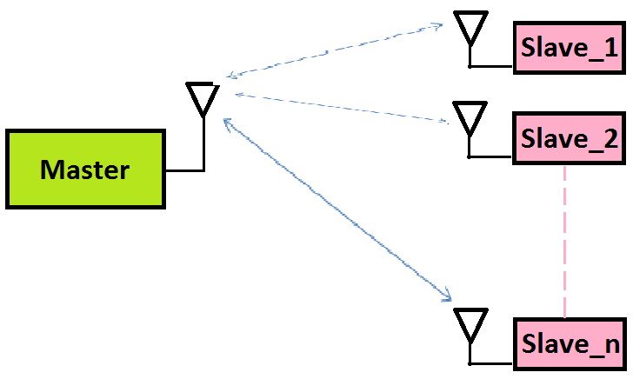

**Fig.2**

**Task:-**

As shown in (**FIG.2),** if we want to add NRF24L01, we need an application to test it so we selected a star network topology. Due to the experiment which we want to do, we decided to make this application as cheap as possible. we interfaced every microcontroller attach to only one NRF24L01 and the only way to do that is to use half duplex communication technique. Also we chose a very common known and cheap microcontroller; it is **ATmega16A** that match our application properly. As it has ***4******I/O*** *ports* and has **SPI** serial communication device embedded in it. That allows us to communicate with NRF24L01 and also have **UART**, **I2C** and many features that can be useful to build many applications based on this application.

**Code explanation:-**

Important notes:-

1- All this work is totally based on the **NRF24L01** and **ATmega16A** datasheets. All the information we need will be in appendix of this chapter, and there will be also page numbers referred to these datasheets for additional information.

**NRF24L01 datasheet link:-**

<https://www.sparkfun.com/datasheets/Components/SMD/nRF24L01Pluss_Preliminary_Product_Specification_v1_0.pdf>

**ATmega16A datasheet link:-**

<http://www.atmel.com/Images/Atmel-8154-8-bit-AVR-ATmega16A_Datasheet.pdf>

2- The code which has been written aims to make the user understand and modify the code very easy without the need to return to datasheets and begins from the scratch. This means the user can control the features and devices which are embedded in **NRF24L01** by using the functions that were already built. Everyone can use it easily and choose the properties that they want (like enabling low noise amplifier, determine pipeline and payload widths, choosing operating baud rate …………. etc.

**Code configuration: -**

Step1: -

To make programming as easy as possible, we should avoid using numbers which are meaningless and try to use constant variables that hold these numbers but have physical meaning and make things easy to use, so we define constant variables that hold memory addresses, most usable bits, instruction mnemonics and some useful constants that have a physical meaning.

Here is the declaration for all of the registers and its bits:-

/* Memory Map */

#define CONFIG 0x00

#define EN_AA 0x01

#define EN_RXADDR 0x02

#define SETUP_AW 0x03

#define SETUP_RETR 0x04

#define RF_CH 0x05

#define RF_SETUP 0x06

#define STATUS 0x07

#define OBSERVE_TX 0x08

#define CD 0x09

#define RX_ADDR_P0 0x0A

#define RX_ADDR_P1 0x0B

#define RX_ADDR_P2 0x0C

#define RX_ADDR_P3 0x0D

#define RX_ADDR_P4 0x0E

#define RX_ADDR_P5 0x0F

#define TX_ADDR 0x10

#define RX_PW_P0 0x11

#define RX_PW_P1 0x12

#define RX_PW_P2 0x13

#define RX_PW_P3 0x14

#define RX_PW_P4 0x15

#define RX_PW_P5 0x16

#define FIFO_STATUS 0x17

#define DYNPD 0x1C

#define FEATURE 0x1D

/* Bit Mnemonics */

#define MASK_RX_DR 6

#define MASK_TX_DS 5

#define MASK_MAX_RT 4

#define EN_CRC 3

#define CRCO 2

#define PWR_UP 1

#define PRIM_RX 0

#define ENAA_P5 5

#define ENAA_P4 4

#define ENAA_P3 3

#define ENAA_P2 2

#define ENAA_P1 1

#define ENAA_P0 0

#define ERX_P5 5

#define ERX_P4 4

#define ERX_P3 3

#define ERX_P2 2

#define ERX_P1 1

#define ERX_P0 0

#define AW 0

#define ARD 4

#define ARC 0

#define PLL_LOCK 4

#define RF_DR 3

#define RF_PWR 6

#define RX_DR 6

#define TX_DS 5

#define MAX_RT 4

#define RX_P_NO 1

#define TX_FULL 0

#define PLOS_CNT 4

#define ARC_CNT 0

#define TX_REUSE 6

#define FIFO_FULL 5

#define TX_EMPTY 4

#define RX_FULL 1

#define RX_EMPTY 0

#define DPL_P5 5

#define DPL_P4 4

#define DPL_P3 3

#define DPL_P2 2

#define DPL_P1 1

#define DPL_P0 0

#define EN_DPL 2

#define EN_ACK_PAY 1

#define EN_DYN_ACK 0

/* Instruction Mnemonics */

#define R_REGISTER 0x00

#define W_REGISTER 0x20

#define REGISTER_MASK 0x1F

#define ACTIVATE 0x50

#define R_RX_PL_WID 0x60

#define R_RX_PAYLOAD 0x61

#define W_TX_PAYLOAD 0xA0

#define W_ACK_PAYLOAD 0xA8

#define FLUSH_TX 0xE1

#define FLUSH_RX 0xE2

#define REUSE_TX_PL 0xE3

#define NOP 0xFF

/* Non-P omissions */

#define LNA_HCURR 0

/* P model memory Map */

#define RPD 0x09

/* P model bit Mnemonics */

#define RF_DR_LOW 5

#define RF_DR_HIGH 3

#define RF_PWR_LOW 1

#define RF_PWR_HIGH 2

Variables declaration here is the same as the described by **NRF24L01** datasheet in pages (46-47 and from 53 to 58). To make it easy, you can return to datasheet.

#define CSN_low PORTB &= ~(1<<PINB1)

#define CSN_high PORTB |= (1<<PINB1)

#define CE_low PORTB &= ~(1<<PINB0)

#define CE_high PORTB |= (1<<PINB0)

#define three_bytes 0x01

#define four_bytes 0x02

#define five_bytes 0x03

#define enable_lna 1

#define disable_lna 0

#define need_0dbm 0x03

#define need_minus6dbm 0x02

#define need_minus12dbm 0x01

#define need_minus18dbm 0x00

#define need_1mbps 0

#define need_2mbps 1

#define tx_mode 0

#define rx_mode 1

#define enable_crc 1

#define disable_crc 0

#define crc_onebyte 0

#define crc_twobytes 1

#define power_up 1

#define power_down 0

#define data_recieved 1

#define data_not_recieved 0

Variables declaration is made to make code understandable and modifiable.

Step 2:-

Creating functions that will make the control of **NRF24L01** very easy and more reliable.

void spi_init()

{

DDRB |= ((1<<PINB7)|(1<<PINB5)|(1<<PINB4)|(1<<PINB0)|(1<<PINB1));

PORTB |= (1<<PINB4);

SPCR=(1<<SPE)|(1<<MSTR)|(1<<SPR0);

CSN_high;

CE_low;

_delay_ms(10);

}

This function is used to initialize the communication between **NRF24L01** and **ATmega16A** through **SPI** (serial peripheral interface) protocol.

So by knowing the pin configuration of **ATmega16A** and **NRF24L01,** we can connect them correctly as shown in **FIG.3.**

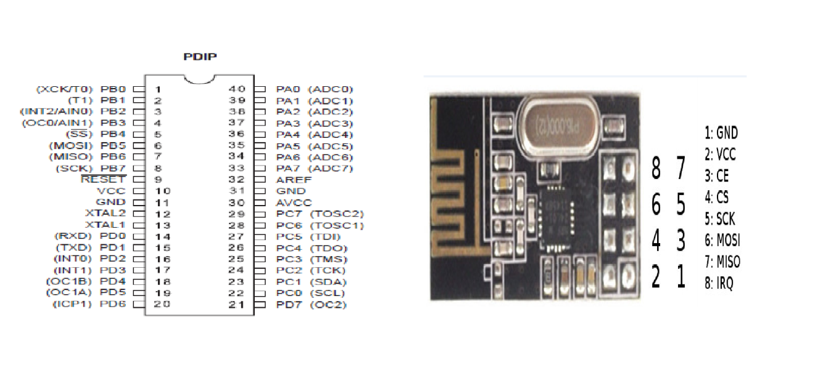

**Fig .3**

**Hardware specifications:-**

To be more specified before talking about the code we should talk about the hardware that makes the circuit and SPI protocol work.

A- How SPI protocol work?

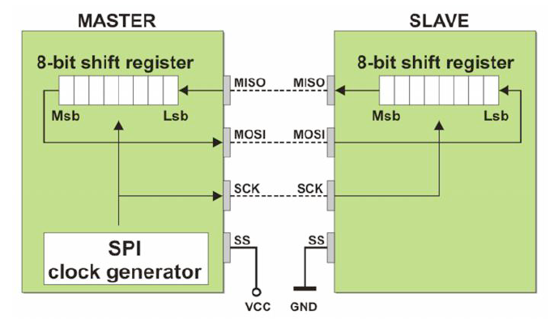

**Fig .4**

As seen in (**FIG.4**), **SPI** is considered as a two 8-bit shift registers which work with the same clock; that means the two shift registers must have the same frequency, phase and polarity. So, there is a pin in the two devices which is responsible for establishing a communication using **SPI** to connect the generated clock by master device to slave device to ensure that the two devices work with the same clock and communication established well without any fault. It is called SCK (serial clock)

From the (**FIG.4),** we can deduce that the exchange of the data in both master and slave happens like as a loop way (shift the data to left and rotate) after exactly 8 clock cycles, the exchange of data between master and slave is completed at the same time. So, it is considered as full duplex protocol.

The two pin are responsible for the exchange of the data which are called **MOSI** (master output slave input) and **MISO** (mater input slave output).

Finally, **SS** pin (**slave select**): it is designed to make the communication with many slaves for example in **ATmega16A.** If we programmed this pin as input pin and programmed **ATmega16A** to be slave using special function registers as we will see later, this pin must be low otherwise SPI will not work in this slave and vice versa. For master device that **SS** must be input high. Unfortunately, we will not benefit from this feature, because in our project task, we have only one master and one slave only.

We also have another benefit in **ATmega16A** thatif we make this pin as output we can control the beginning and the ending of the sending data. As ((if **SS** is low)) that means the beginning of the sending data to slave and ((if **SS** is high)) that means the ending of the sending data and stopping the communication between the master and slave. This can be useful to ensure that data was sent correctly and reduce the effect of any problem that could be happened in the communication channel like interference ....etc.

**By dividing the time into two intervals:-**

1- The time of beginning of sending data to the ending of sending it.

2- Free time included in which there is no exchange of the data between the master and slave (**SPI IS off**) until **SPI** is established again.

So, we can deduce the Schematic circuit which is shown in the following figure: -

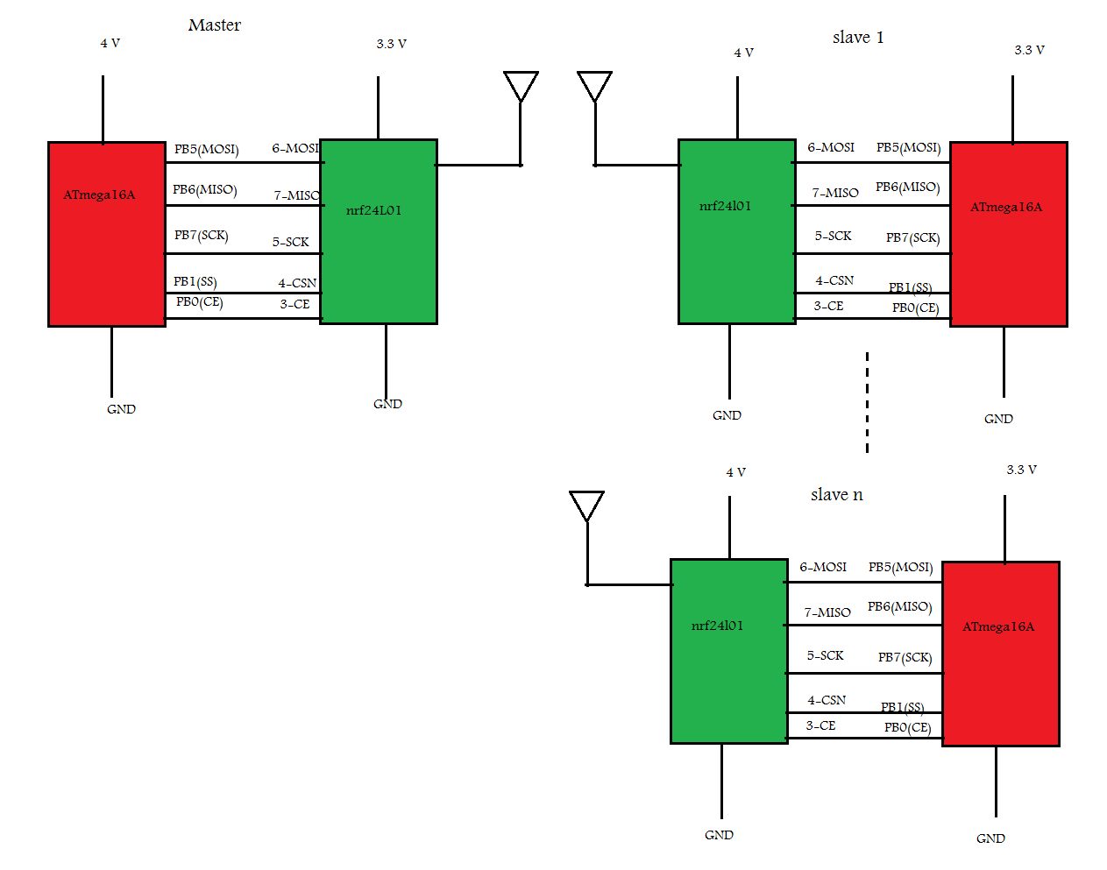

**Fig.5**

This is exactly the star network schematic circuit that we are using in our mini project. All pins connections are illustrated above except for **CE** pin, and the importance of this pin comes from this reason which is we actually have two kinds of communications here.

1- Serial communication between **ATmega16A** (act as master here) and NRF24L01 module (act as a slave here) that was established by **SPI** protocol.

2- Wireless communication between NRF24L01 modules itself.

So, as SS or CSN (SPI chip select) (the2 names mean the same here) pin controls the time beginning and ending of data from ATmega16A to nrf24L01

The same thing for CE pin it enables ATmega16a to control the time beginning and ending of data from NRF24L01 itself to another NRF24L01.

**ATmega16A SPI special registers: -**

In **ATmega16A** there are 3 registers that control the whole process of **SPI** communication: -

1- **SPSR** (serial peripheral status register): -

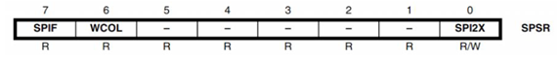

This register has only 3-bits and the remaining are reversed. These bits are:-

A- BIT7 **SPIF** (serial peripheral interrupt flag)

The most important function of this interrupt bit is its value become **1** when **SPI** finish exchanging data.

B- BIT6 **WCOL** (write collision flag)

This bit is being set when **ATmega16A** trying to fill **SPDR** register during the exchanging of data process.

C- BIT0 **SPI2X**

This bit is used to double the speed of exchanging the data (double baud rate)

**Note**: this will be discussed later when explaining **SPCR** register.

2- **SPCR** (serial peripheral control register)

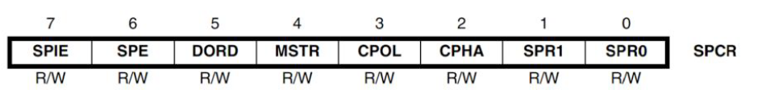

This register has 8-bits to control **SPI** communication process.

A- **SPR0** and **SPR1** are controlling the serial clock frequency and **SPI2X** which included in **SPSR**.

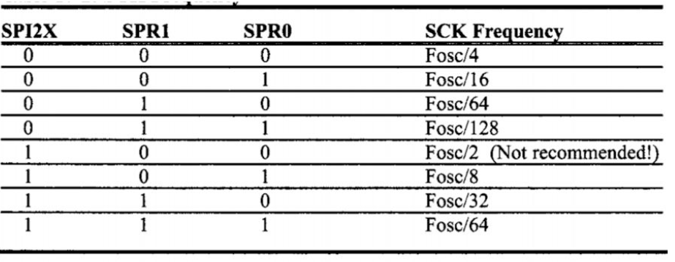

**Table.1**

As shown in (**Table.1**) each value has corresponding **SCK** frequency that vary from Fosc/128 to Fosc/2 where Fosc is the frequency that **ATmega16A** works at. In our code, we use **ATmega16A** internal generation frequency =1MHZ and make **SPR0**=1 (set **SPR0**) this make SCK frequency=1MHZ/16 = 62.5 KHz

B- **SPIE** (Serial peripheral interrupt enable):- when setting it the interrupt in the **SPI** will be enabled.

C- **SPE** (Serial Peripheral Enable):- set this bit will enable **SPI** protocol in **ATmega16A** microcontroller.

D- **DORD** (data order): when setting it, the LSB will be sent first, when disabling it, the MSB will be sent first.*

E- **MSTR**: when setting it, this mean **ATmega16A** works as a master when it equal to zero, **ATmega16A** works as a slave.

F- **CPOL**, **CPHA**: these bits are used to change the clock polarity, phase and to make SPI communication operated successfully. These bits must have the same values in master and all slaves.

3- **SPDR** (Serial Peripheral Data Register):- this register is 8-bit width, and we use it to load data that we want to transmit.

After knowing well how to initialize **SPI** protocol in both **ATmega16A** and **NRF24L01**, now we are going to know more about NRF24L01 registers and its functions so we find a summary in NRF24L01 datasheet in the pages (from 53 to 58). The following tables are the reference of the whole functions we used in our code. We understood it well and start form the suitable functions which are needed to complete the communication process.

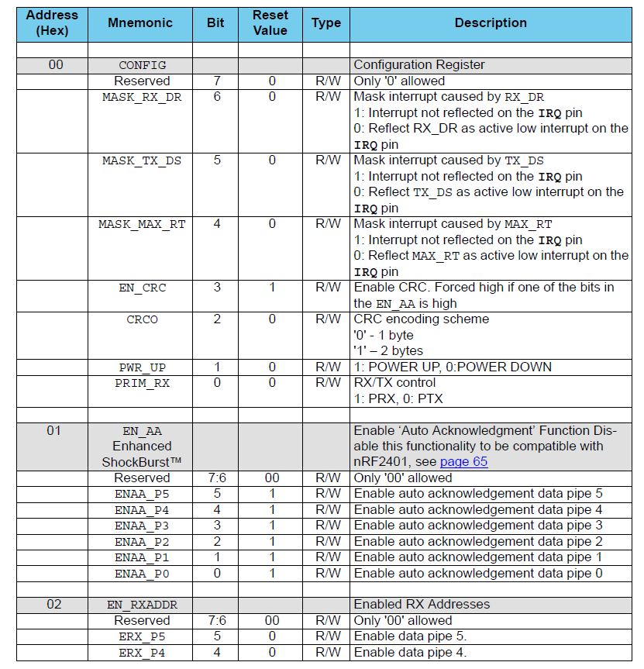

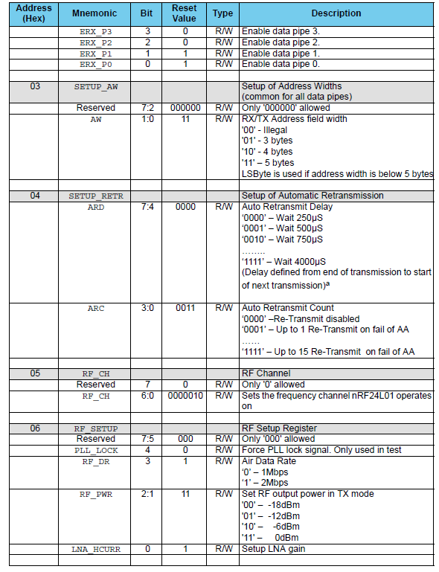

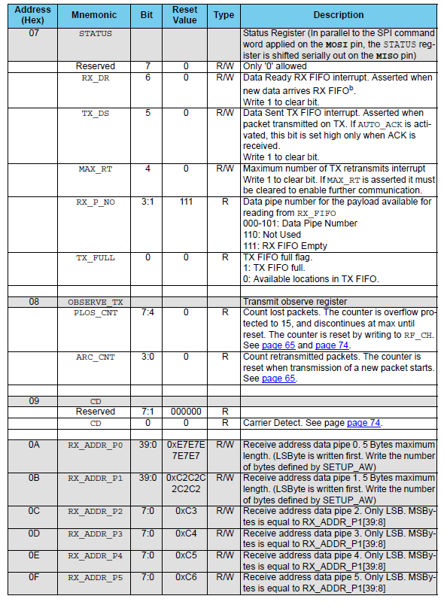

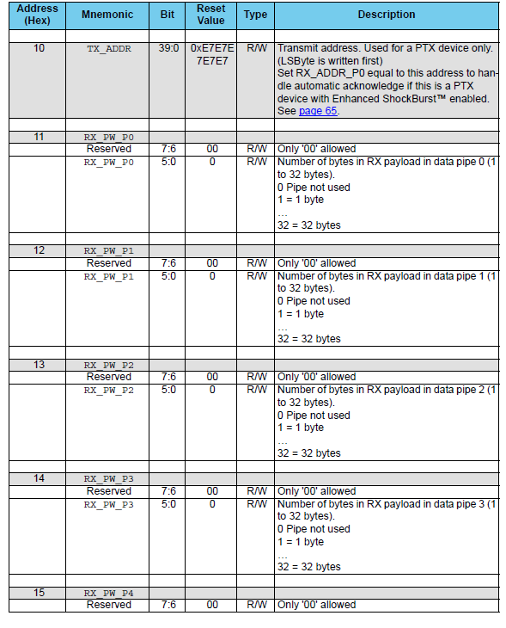

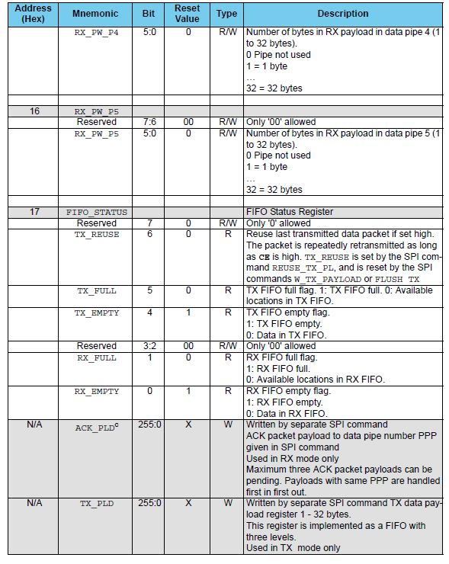

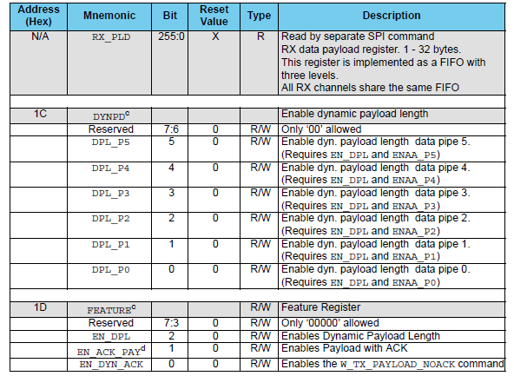

**Summary of the instructions which are used in NRF24L01**

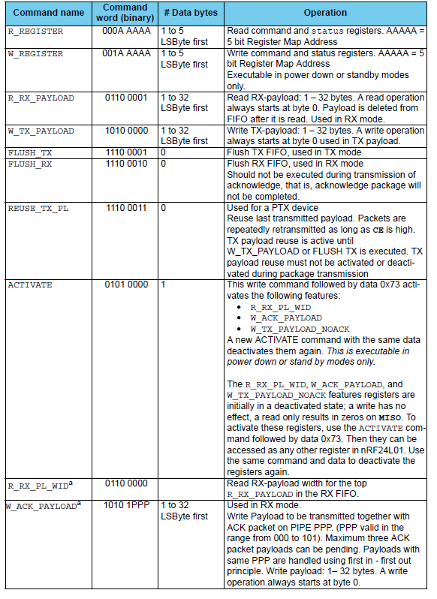

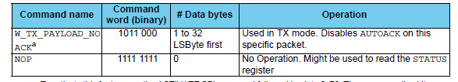

By using all of the information in the above tables, we can construct our functions and build the code properly.

The detailed code will be the next step to explain (the formation of the code and its instructions).

void spi_init()

{

// SCK MOSI CE CSN

DDRB |= ((1<<PINB7)|(1<<PINB5)|(1<<PINB4)|(1<<PINB0)|(1<<PINB1));//set these bits as output

PORTB |= (1<<PINB4);// set ATmega16A slave select bit as high

// note that PINB4 is ATmega16A initial slave select and as SPI can have many slave select we make this bit as output

//and set it high as we assume there is a imaginary device beside nrf24L01 and making set SS as high will cut the communication between

//this imaginary device and ATmega16A and all of this to make us able to use any bit instead of this specific bit PINB4 as slave select(CSN bit)

SPCR=(1<<SPE)|(1<<MSTR)|(1<<SPR0);// this a specific register in ATmega16A used to enable SPI and determine ATMEGA is a master and

//use clock freq = F(osc)/16=1MHz/16=62.5kbPs

CSN_high;// no communication between ATmega16A and NRF24L01

CE_low;// no communication between NRF24L01 and another NRF24L01

_delay_ms(10);

}

uint8_t spi_sendreceive(uint8_t mydata)

// used this function to send ( from ATmega16A to nrf24L01) and receive(from nrf24L01 to ATmega16A) data

// this happened in same time as SPI is a full duplex protocol

{

SPDR=mydata;// this the special register in ATmega16A that hold the wanted data to be transmitted through SPI protocol

while(!(SPSR & (1<<SPIF)));// wait until SPIF(serial peripheral interrupt flag)bit have a value =1 in SPSR(serial peripheral status register)

// that mean when SPIF bit =1 the process of sending and receiving data had been completed.

return SPDR;

}

uint8_t*nrf_readregister(uint8_t reg,uint8_t noval)

//this function consist of 2 arguments first the register that uc want to read inside nrf24l01

//second the width of that register in bytes.

//here uc try to read status register in nrf24l01 as it is very important register as it has many interrupt bits that will help us to take decisions

{

int i;

static uint8_t retdata[32];

CSN_low;// begin SPI communication

spi_sendreceive(reg);// send the address of wanted register in nrf24L01 memory that i want write in it and read from it

//here i write in register only as there is no return value

/*very important note

due the fact that SPI will change the content of memory register they divide it to 2 locations every location have all the special function registers

but the only difference between them one is specified to read from it only and the other to write in it only so to differ between read and write registers

they give a least significant 5 bit for the the address of them and the most significant 3 bits to know if its read or write register

000 for a read register 001 for write register ex :-status register the read register address 0000 0111 and the write register 0010 0111

*/

for(i=0;i<noval;i++)

{

retdata[i]=spi_sendreceive(NOP);//send a redundant (no operation) byte to the specified read register to read its contents

}

CSN_high;// end SPI communication

return retdata;

}

void nrf_writeregister(uint8_t reg,uint8_t *regdata,uint8_t noval)//this function take 3 arguments first the address of the register

//second the data that we want to write in the register,the the third is the width of the data in bytes

{

int i;

CSN_low;// begin SPI COMMINICATION

spi_sendreceive(W_REGISTER|reg);// send address of the write register (this is done by or the write instruction with address of register that is actually written in read register way

for(i=0;i<noval;i++)

{

spi_sendreceive(regdata[i]);// send data to the specified register

}

CSN_high;//end SPI communication

}

//

void enable_ack_inpipe(uint8_t x)

{

uint8_t y[1];

y[0]=1<<x;

nrf_writeregister(EN_AA,y,1);// write the configuration value to enable auto acknowledge register in nrf24l01 memory

}

void enable_pipe (uint8_t x)

{

uint8_t y[1];

y[0]=1<<x;

nrf_writeregister(EN_RXADDR,y,1);// write the configuration value to enable receiver address register in nrf24l01 memory

}

void pipe_address_width(uint8_t x)

{// only 2 bit allowed to be written

uint8_t y[1];

y[0]=x;

nrf_writeregister(SETUP_AW,y,1);// write the configuration value to setup address width register in nrf24l01 memory

}

void set_retries(uint8_t delayk,uint8_t num)

{

// try it each step in time has 250us range of retries is from 0=>15 in both time and number of retries

uint8_t y[1];

y[0]=(delayk<<4)|num;// 8 bit (delayk (most significant nibble) num (least significant nibble))

nrf_writeregister(SETUP_RETR,y,1);// write the configuration value to setup retries register in nrf24l01 memory

}

void set_nrf_freq(uint8_t x)

{// only 7 bits are allowed to write in it

uint8_t y[1];

y[0]=x;

nrf_writeregister(RF_CH,y,1);// write the configuration value to radio frequency channel register in nrf24l01 memory

}

void set_rf_register (uint8_t air_data_rate,uint8_t rf_power,uint8_t lna)

{

uint8_t x=0;

uint8_t y[1];

if (air_data_rate==need_2mbps)

{

x|=(1<<RF_DR);

}

else if(air_data_rate==need_1mbps)

{

x&=~(1<<RF_DR);

}

if (rf_power==need_0dbm)

{

x|=(1<<RF_PWR_LOW)|(1<<RF_PWR_HIGH);

}

else if(rf_power==need_minus6dbm)

{

x|=(1<<RF_PWR_HIGH);

x&=~(1<<RF_PWR_LOW);

}

else if(rf_power==need_minus12dbm)

{

x|=(1<<RF_PWR_LOW);

x&=~(1<<RF_PWR_HIGH);

}

else if(rf_power==need_minus18dbm)

{

x&=~(1<<RF_PWR_HIGH);

x&=~(1<<RF_PWR_LOW);

}

if (lna==enable_lna)

{

x|=(1<<LNA_HCURR);

}

else if(lna==disable_lna)

{

x&=~(1<<LNA_HCURR);

}

y[0]=x;

nrf_writeregister(RF_SETUP,y,1);// write the configuration value to radio frequency setup register in nrf24l01 memory

}

void set_rx_address(uint64_t address,uint8_t pipe_num,uint8_t pipe_width)

{

uint8_t x[pipe_width];

uint8_t i;

for(i=0;i<pipe_width;++i)

{

x[i]=(uint8_t)(address>>8*i);// the address written here from low significant byte(LSB) to most significant byte(MSB)

//x[0] has LSB x[pipe_width-1] has MSB

//note that RX_ADDR_Pk (receiver address pipe k)as k=0 or 1 ...or5 read address from LSB (byte) first to MSB (byte)

}

if(pipe_num==0)

{

nrf_writeregister(RX_ADDR_P0,x,pipe_width);

}

else if (pipe_num==1)

{

nrf_writeregister(RX_ADDR_P1,x,pipe_width);

}

else if (pipe_num==2)

{

nrf_writeregister(RX_ADDR_P2,x,pipe_width);

}

else if (pipe_num==3)

{

nrf_writeregister(RX_ADDR_P3,x,pipe_width);

}

else if (pipe_num==4)

{

nrf_writeregister(RX_ADDR_P4,x,pipe_width);

}

else if (pipe_num==5)

{

nrf_writeregister(RX_ADDR_P5,x,pipe_width);

}

}

// tx address must equal pipe 0 address if u will work with ack mode

void set_tx_address(uint64_t address,uint8_t pipe_width)

{

uint8_t x[pipe_width];

uint8_t i;

for(i=0;i<pipe_width;++i)

{

x[i]=(uint8_t)(address>>8*i);// the address written here from low significant byte(LSB) to most significant byte(MSB)

//x[0] has LSB x[pipe_width-1] has MSB

//note that RX_ADDR_Pk as k=0 or 1 ...or5 read address from LSB (byte) first to MSB (byte)

}

nrf_writeregister(TX_ADDR,x,pipe_width);// write the configuration value to transmit address register in nrf24l01 memory

}

void rx_payload_width(uint8_t width,uint8_t pipe_num)

{

uint8_t y[1];

y[0]=width;

if (pipe_num==0)

{

nrf_writeregister(RX_PW_P0,y,1);

}

else if (pipe_num==1)

{

nrf_writeregister(RX_PW_P1,y,1);

}

else if (pipe_num==2)

{

nrf_writeregister(RX_PW_P2,y,1);

}

else if (pipe_num==3)

{

nrf_writeregister(RX_PW_P3,y,1);

}

else if (pipe_num==4)

{

nrf_writeregister(RX_PW_P4,y,1);

}

else if (pipe_num==5)

{

nrf_writeregister(RX_PW_P5,y,1);

}

}

// try this function and check it

void enable_dynamic_payload_inpipe(uint8_t pipe_num)// this function used to enable dynamic payload feature in nrf24l01 in any pipe i want

// here we do not use it in our code as we do not need it

//note that dynamic means there is no need to determine the width of data transmitted but we use static payload that mean every time we must determine

//the width of data transmitted at once.

{uint8_t y[1];

y[0]= (1<<EN_DPL);

nrf_writeregister(FEATURE,y,1);//set enable dynamic payload bit in feature register in nrf24L01 memory

if (pipe_num==0)

{

y[0]=(1<<DPL_P0);//dynamic payload in pipe 0 bit

nrf_writeregister(DYNPD,y,1);// write configuration value to dynamic payload register in nrf24L01 register

// note dynamic payload register have 6 bits (5:0) every bit control the enable or disable dynamic payload feature in each corresponding pipe

}

else if (pipe_num == 1)

{

y[0]=(1<<DPL_P1);

nrf_writeregister(DYNPD,y,1);

}

else if (pipe_num == 2)

{

y[0]=(1<<DPL_P2);

nrf_writeregister(DYNPD,y,1);

}

else if (pipe_num == 3)

{

y[0]=(1<<DPL_P3);

nrf_writeregister(DYNPD,y,1);

}

else if (pipe_num == 4)

{

y[0]=(1<<DPL_P4);

nrf_writeregister(DYNPD,y,1);

}

else if (pipe_num == 5)

{

y[0]=(1<<DPL_P5);

nrf_writeregister(DYNPD,y,1);

}

}

void config_nrf(uint8_t nrf_mode,uint8_t enable_or_disable_crc,uint8_t crc_scheme,uint8_t power)

{

uint8_t x=0;

uint8_t y[1];

if(nrf_mode==tx_mode)

{

x&=~(1<<PRIM_RX);

}

else if (nrf_mode==rx_mode)

{

x|=(1<<PRIM_RX);

}

if(enable_or_disable_crc==disable_crc)

{

x&=~(1<<EN_CRC);

}

else if (enable_or_disable_crc==enable_crc)

{

x|=(1<<EN_CRC);

}

if(crc_scheme==crc_onebyte)

{

x&=~(1<<CRCO);

}

else if (crc_scheme==crc_twobytes)

{

x|=(1<<CRCO);

}

if(power==power_down)

{

x&=~(1<<PWR_UP);

}

else if (power==power_up)

{

x|=(1<<PWR_UP);

}

y[0]=x;

nrf_writeregister(CONFIG,y,1);// write the configuration value to configuration register in nrf24l01 memory

}

/*

TX FUNCTIONS

*/

void nrf_tx(uint8_t *mydata,uint8_t payload_width)

{

uint8_t i;

CSN_low;//begin spi communication

spi_sendreceive(FLUSH_TX);// send FLUSH_TX instruction to nrf24L01 to make it prepare to receive the coming payload data from ATmega16A (it is like a yellow color in traffic light)

CSN_high;// end SPI communication

_delay_ms(1);

CSN_low;//begin spi communication

spi_sendreceive(W_TX_PAYLOAD);// send W_TX_payload (write transmitter payload)instruction to nrf24L01 before directly write payload data (it is like a green color in traffic light)

// as we understand from the above comment W_TX_payload instruction shows nrf24l01 that every data coming after that instruction is basically the data we want to transmit so

//this instruction must be attached to payload data in the same SPI packet so we do not close SPI to actually attach payload data make all of the in the same packet

for(i=0;i<payload_width;i++)

{

spi_sendreceive(mydata[i]);// send payload data

}

CSN_high;//close SPI communication

CE_high;// begin transmit data in nrf24L01 to air using antenna (begin RF communication)

_delay_us(30);

CE_low;//end RF communication

}

void nrf_reset()

{

uint8_t *recvdata;

recvdata=nrf_readregister(STATUS,1);//read status register

recvdata[0]|=(1<<MAX_RT);// to clear MAX_RT bit in STATUS register

nrf_writeregister(STATUS,recvdata,1);// use SPI to modify Status contents(write new values in it)

}

/*

rx functions

*/

// receive data

void nrf_rx()

{

CSN_low;// begin SPI communication

spi_sendreceive(FLUSH_RX);// send FLUSH_RX instruction to nrf24L01 to make it prepare to receive the coming payload data from air (it is like a yellow color in traffic light)

CSN_high;// end SPI communication

CE_high;//begin RF(radio frequency) communication to receive payload in air

_delay_ms(1000);

CE_low;// end RF communication

}

//check data is received correctly or not

uint8_t nrf_rxdataready()

{

uint8_t*recvdata;

recvdata=nrf_readregister(STATUS,1);// read status register in nrf24L01

if(recvdata[0]&(1<<RX_DR))// check RX_DR bit in nrf24L01 status register to see if it is set(data correctly received) or not(data not received)

{

return data_recieved;

}

else

{

return data_not_recieved;

}

}

//passing data to MU memory from nrf

uint8_t* nrf_readdata(uint8_t payload_width)

{

int i;

static uint8_t recvdata[5];

CSN_low;//begin SPI communication

spi_sendreceive(R_RX_PAYLOAD);// send R_RX_PAYLOAD instruction in the beginning of packet to shows nrf24L01 ATmega16A will read the received payload from air

/*very important note

to successfully load received payload data from nrf24L01 we must put R_RX_PAYLOAD instruction in the beginning of SPI packet

*/

for(i=0;i<payload_width;i++)

{

recvdata[i]=spi_sendreceive(NOP);//ATmega16A load receiving payload from nrf24L01 and save it in its internal memory

}

CSN_high;// end SPI communication

return recvdata;

}

uint8_t digital_read(uint8_t reg,uint8_t pin_num)//this function read the input logic (VCC (1) or GND(0)) to any pin in ATmega16A by

//giving it 2 argument first pin register name second pin number in that pin register and return 1 if the input logic =VCC or 0 if input logic=GND

{

uint8_t x;

x=reg&(1<<pin_num);

if (x!=0)

{

x=1;

}

return x;

}

Step3:-

Using produced functions to write our code:-

****************************************************************************************************

**Here is the Transmitter code we wrote with details and more illustration about our built functions: -**

We supposed in our application that we have one master and 2 slaves for simplification only, but it could be extended easily.

#include <avr/io.h>

#define F_CPU 1000000UL

#include <util/delay.h>

const uint64_t pipe[2] = {0xE8E8F0F0E1LL,0x1212121234LL};//these are the addresses of the 2 slaves that master will communicate with

int main(void)

{

//these comments below to illustrate the job of each function used in this code

spi_init();// initialize SPI protocol in ATmega16A

enable_pipe(0); // enable pipe 0 from 6 pipes numbered from 0=>5 in nrf24L01

enable_ack_inpipe(0); // enable auto acknowledge mode in pipe 0

//.so the tx and rx must have the same address to make this mode work according to datasheet

//auto acknowledge mode used to handle transmission and receiving process (automatic) when only making CE high

pipe_address_width(five_bytes);// this function determine the all pipes width at once here all pipes=5bytes=40bit width

set_retries(15,15);//this function determine the number of payload retransmission(num) and the time interval(delay) between each retransmission

// void set_retries(uint8_t delay,uint8_t num); delay and num each of them have 4 bits only so the maximum value of number of payload retransmission(num)

// number of payload retransmission(num)=15. 0 means disable retransmission.

//for delay 0 means wait 250us 1=>500us each counting has 250us this mean maximum delay=16*250us=4000us=4ms

set_nrf_freq(0x02);// this function determine the center frequency(carrier frequency) we have 126 RF channels determined by 7 bits (6:0)

//bit 7 is always 0 the non overlapping spacing is depend on data rate 0x00 and 0x7f are not allowed as there are the beginning

// and the ending of freq band so it must begin from 0x01=>0x7E.

//side note (my estimation it is from 2.4GHz=>2.8524GHZ by using this equation fc=(1.8*Rb*channel number-Rb)/1000+2.4 so fcat channel 126=2.8516

//so end band =fc@channel 126+0.4*Rb/1000=2.8524 GHZ assuming RB=2MbPS.)

set_rf_register(need_2mbps,need_0dbm,enable_lna);

//this function used to determine the setup of radio frequency u want in your application for only these

//three parameters air data rate (1 and 2MbPS are the only available data rate in the module ) ,output power in TX mode in dbm (0,-6.-12,-18)are also the only available power values

//and use LNA(low noise amplifier ) or not

rx_payload_width(5,0);// this function has 2 arguments the first is the width of the payload that we want to transmit it vary from 1-32 bytes

// but we choose here 5 bytes only to be transmitted at once the second argument is the pipe number that the payload will be transmitted through

config_nrf(tx_mode,enable_crc,crc_twobytes,power_up);

//this function has 4 arguments:-

// the first determine the mode of nrf24l01 if it is tramsmiter (tx) or receiever(rx)

//the second make the user choose if he want to use error detection using crc method by enabling it or not

// the third depend on the second argument if crc is not enabled it will have no effect

// it determine the crc coding scheme (1byte or 2 bytes only available) as the width of crc increased as nrf24l01 has more

//ability to correct the error bits received at receiver .

//the forth control the job of nrf24l01 basically ,power up means nrf24l01 turns on,power down nrf24lo1 turns off

//code:-

DDRA=0XFF;// connect seven segment

DDRD|=(1<<PIND0);// connect detection led

PORTD|=(1<<PIND1)|(1<<PIND2)|(1<<PIND3)|(1<<PIND4)|(1<<PIND5)|(1<<PIND6);//connect 6 switch that work on active low

//(first 2 of them PIND1 an PIND2 used to switch between the 2 receivers and from PIND3(LSB)=>PIND6(MSB) used to enter numberS from0=>15.

uint8_t mydata[]={10,11,12,13,14};// initial data has no meaning here

uint8_t*recvdata;

uint8_t z,s;

z=0;

s=0;

while(1)

{

//TODO:: Please write your application code

/*

tx code */

//as this is the master code it should initially transmit the data first to the selected slave then recieve the data from it.

config_nrf(tx_mode,enable_crc,crc_twobytes,power_up);

label1:

if((digital_read(PIND,1)==0)&&(digital_read(PIND,2)==0))

{

// the hole idea based on the fact that if the master and slave there will be communication between them else no communication will be established

//set slave1 address

set_rx_address(pipe[0],0,5);//this function has 3 arguments first the address value,the second pipe number that will save this address value

//the third is width of used pipe (note if the width of the written address > width of pipe this function will take only

//the exact needed width of the written address from the LSB to MSB ex:- pipe width =40bit rx_address width=56bit pipe address=first40bit from rx_address

//from LSB to MSB )

set_tx_address(pipe[0],5);

//this function has 2 argument first address value,second width of pipe (the same note mentioned in set_rx_address() function will work here also

// due we are in ack mode so tx and rx address must be the same as mentioned in nrf24l01datasheet

}

else if((digital_read(PIND,1)==0)&&(digital_read(PIND,2)==1))

{

//set slave 2 address

set_rx_address(pipe[1],0,5);

set_tx_address(pipe[1],5);

}

/*

Write your application code here that you want apply in transmission process and save the data you want transmit in mydata array

mydata[1]=……..

*/

nrf_tx(mydata,5);//this function take 2 arguments,first the packet(payload) that we want to transmit,second the width of that packet(payload)

recvdata=nrf_readregister(STATUS,1);//this function consist of 2 arguments first the register that uc want to read inside nrf24l01

//second the width of that register in bytes.

//here uc try to read status register in nrf24l01 as it is very important register as it has many interrupt bits that will help us to take decisions

if(recvdata[0]& (1<<MAX_RT))//check bit MAX_RT in nrf status register as if it has value 1 means the communication stopped

// and we need to clear it to enable further communication

{

nrf_reset();// this the responsible function to write 1 to MAX_RT bit in status register to clear this bit and enable communication again.

if(s<15)

{

s++;

goto label1;// return to begging of the code to try to re communicate with the same slave and retransmit the same byte or establish new communication

// with new slave with new data according to the situation

}

s=0;// we here try to make mater not being stuck at tx_code loop instead making wait for awhile and when communication is not established master jump to rx_code

// to ensure communication will happen

}

else if(recvdata[0]& (1<<TX_DS))//check TX_DS interrupt bit in status register if it has value 1 this mean the transmission is completed successfully

{

//led on to show us that our data sent successfully

PORTD|=(1<<PIND0);

}

_delay_ms(100);

PORTD&=~(1<<PIND0);//turn off led

/* rx code

*/

// the receiving stage for the master after transmission

/*

very important note!

to establish communication right initially master should start with tX mode then RX mode the opposite for slaves that should start with rx mode then tx mode

all of the above configurations to ensure synchronizations between master and slaves and if all of them start with tx mode then rx mode or opposite

// all nrf24l01 modules will be stuck in tx mode or rx mode for ever and communication will never be established.

*/

config_nrf(rx_mode,enable_crc,crc_twobytes,power_up);// master rx mode

label2:

nrf_rx();// this function receive the transmitted data from the air

if(nrf_rxdataready()==data_recieved)//this function check RX_DR interrupt bit in status register and if it has value 1 it means

// the data is successfully received else (value 0) it means there is error in the received signal

{

recvdata=nrf_readdata(5);// this function take the width of the received payload data and try to get it from nrf memory through

//SPI protocol

/*

Write your application code that apply in rx_mode by taking values from

recvdata and making your operation on it

.

.

.

*/

}

else

{

if(z<15)

{

z++;

goto label2;//wait for 15 times until receiving data or resume the code ordinary after finishing 15 tries.

}

z=0;

}

}

}

**\*\*\*\*\*\*\*\*\*\*\*\*\*\*\*\*\*\*\*\*\*\*\*\*\*\*\*\*\*\*\*\*\*\*\*\*\*\*\*\*\*\*\*\*\*\*\*\*\*\*\*\*\*\*\*\*\*\*\*\*\*\*\*\*\*\*\*\*\*\*\*\*\*\*\***

**This is an example for one of the slaves: -**

const uint64_t pipe = 0xE8E8F0F0E1LL;

int main(void)

{

spi_init();

enable_pipe(0);

enable_ack_inpipe(0);

pipe_address_width(five_bytes);

set_retries(15,15);

set_nrf_freq(0x02);

set_rf_register(need_2mbps,need_0dbm,enable_lna);

set_rx_address(pipe,0,5);

set_tx_address(pipe,5);

rx_payload_width(5,0);

config_nrf(rx_mode,enable_crc,crc_twobytes,power_up);

//code:-

DDRA=0XFF;

DDRD|=(1<<PIND0);

uint8_t mydata[]={0,1,2,3,4};

uint8_t*recvdata;

uint8_t l;

while(1)

{

//TODO:: Please write your application code

/*

rx code must come first

*/

config_nrf(rx_mode,enable_crc,crc_twobytes,power_up);

label2:

nrf_rx();

if(nrf_rxdataready()==data_recieved)

{

recvdata=nrf_readdata(5);

/*

Write your application code that apply in rx_mode by taking values from

recvdata and making your operation on it

.

.

.

*/

}

else

{

goto label2;//making slave stuck at rx mode until master communicate it as a transmitter then code continue ordinary

}

/*

tx code must come after rx code

*/

/*

tx code */

config_nrf(tx_mode,enable_crc,crc_twobytes,power_up);

label1:

/*

Write your application code here that you want apply in transmission process and save the data you want transmit in mydata array

mydata[1]=……..

*/

nrf_tx(mydata,5);

recvdata=nrf_readregister(STATUS,1);

if(recvdata[0]& (1<<MAX_RT))

{

nrf_reset();

goto label1;

}

else if(recvdata[0]& (1<<TX_DS))

{

PORTD|=(1<<PIND0);

}

_delay_ms(100);

PORTD&=~(1<<PIND0);

}

}

Note that: any slave program has the same architecture, and the only difference is the address value of the pipe.

**For the previous codes of the master and slave, we can deduce that:-**

Any initial configuration made in master device must made the same in the slave devices, so as we see the 2 codes are almost identical in everything.

Built in function, properties, features…..etc. or communication will fail. Ex: - suppose we made master run at baud rate=2MbPs and slave run at 1MbPs

We will notice that master and slave will not able understand each other, and we will not get any useful data. It will be corrupted, and the code may stuck in the end, as we break the synchronization. This error may happen also if we set SCK frequency in both master and slave at different values.

2- The only difference is in master code we run tx functions before rx functions, and in slave devices the opposite happens rx functions executed before tx functions, and the reason is very simple, as at initial master must first send data and slave must receive data in first and if we don’t do that slaves will stuck in transmission and receiving process respectively and communication will never be established.

And here is a flow chart that illustrates what happen in code in figure 6:-

1. For master we define 2 variables S, Z and we will use them to make master able to skip transmitter and receiver code loops.
2. For that reason, slave devices must be stuck at transmitter or receiver code until master communicates them. Ex :-( if slave at rx_mode it must be stuck at that mode until master move to tx_mode and the communication happen).
3. We initialize NRF24L01 and SPI for master and all slaves with same properties to establish communication between them.
4. The properties we set in code are:- 2MbPS data rate,64.5KHz serial SPI clock,0dbm power, enable low noise amplifier, enable pipe 0 only and auto-acknowledge mode in this pipe 0 only ,enable channel number 2 ,max number of retransmission =15,delay between each transmitted packet=4ms and pipe address width=5bytes.
5. As a result of this Algorithm shown in flow chart in FIG.6, theoretically the maximum number of slaves allowed=240 =1.099*10^12 slaves devices for each master device.
6. As the result of the fact that NRF24l01 has 126 channels. This means the maximum allowed number of master devices =126, so theoretically the total maximum number of slaves =126*240=1.385*10^14 devices.

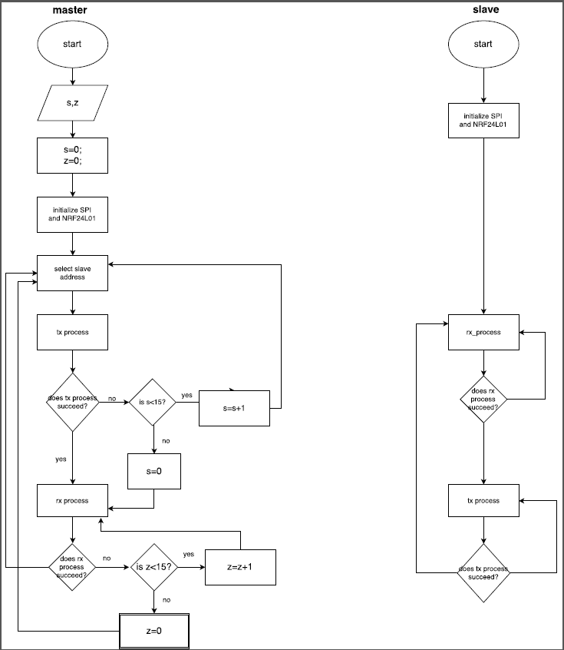

**FIG.6**

**Determination of radio frequency channel frequency:-**

Unfortunately, NRF24L01 datasheet has said nothing about frequency of RF channel. Although there are 126 channels available, no overlap spacing = data rate used and NRF24l01 use GFSK (Gaussian frequency shift keying).

So, we estimate the maximum range of frequency used according to these assumptions: -

Seen in FIG.7

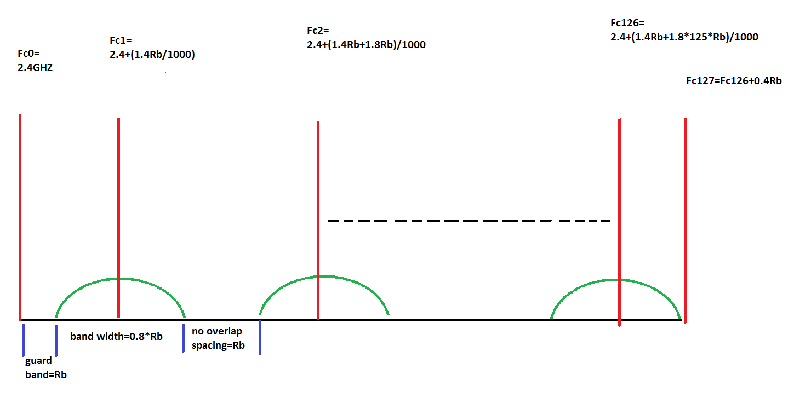

**FIG.7**

Our assumptions are:-

1-There are guard band =data rate used =Rb MHz

2-The bandwidth of transmitted data using GFSK=0.8Rb MHz

So according to FIG.7, we can conclude this mathematical formula:-

Fcn=2.4+ (1.4+1.8*(n-1))*Rb/1000 GHz.

Where n represents RF channel number that varies from 1 till 126.

As seen in figure 7, channel 0 and 127 cannot be used, as there is no space to make us able to transmit any data or interference will occur, so our range used in RF_CH register from 0x01 till 0x7e.

As in our application code, we set air data rate to 2MbPS. So, we substitute in the above

Equation, we get

Fc126=2.4+ (1.4+1.8*125)*2/1000=2.8528 GHZ

So Fc127=Fc126+0.4Rb=2.8528+0.4*0.002=2.8536GHZ.

So theoretically, NRF24l01 has a range from 2.4 to 2.8536 GHZ.

**Hardware circuit test:-**

To test our application code in real life we made a very simple code.

The hardware components required for this test are 6 DIP switches, 2 seven segment common cathode ,2 LEDs (the circuit schematic is shown) :-

Master circuit:-

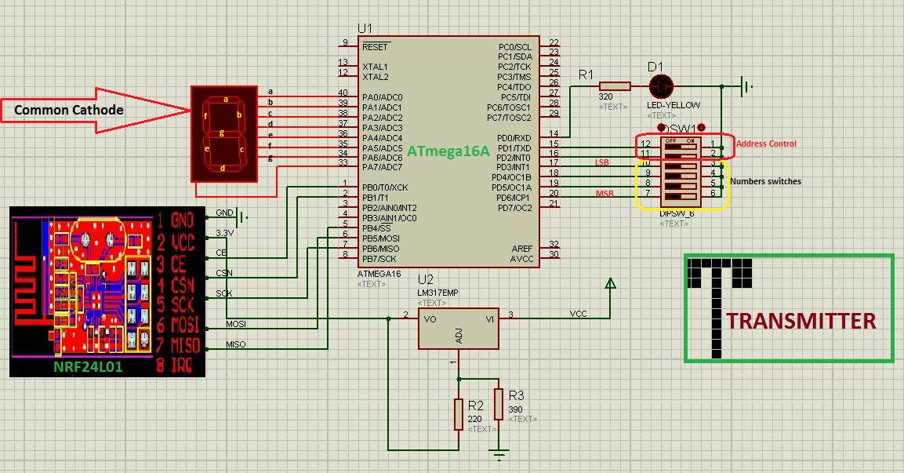

Slave circuit:-

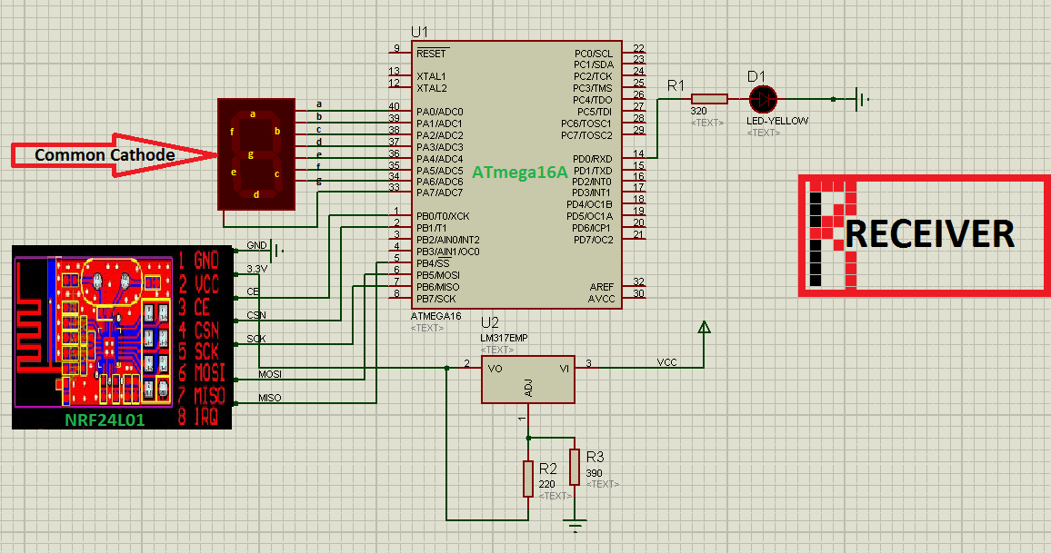

Procedure: - The user should enter number using last 4 switches in binary and choose the one of the 2 slaves by first 2 switches. Slave should show that number in the seven segment, and the slave should increase that number by 1 and retransmit to master that shows that number on his seven segment display.

The benefit of the 2 connected LEDs is to detect if the transmission process in both master and slave is complete or not.

To make things easy. We make 2 functions and declare it in our scratch application. decimal_encode()to convert binary number written by switches to decimal numbers, and decimal_decode() to show the data transmitted in seven segment.

uint8_t decimal_encode(uint8_t swt)// this function read PINx(3,4,5,6)bits as x=A,B,CorD contents then encode it to the corresponding decimal value and returning the result

//this function work in active low topology ex if PIND=0bx111 0xxx this mean the returning encoding number =1 (x here mean do not care)

{

uint8_t y=0;

uint8_t x=0;

x=swt;

x&=0X78;//x=0b0xxx x000(x here represent value of the bits that idonot know)

if(x==0x78)

{

y=0; // Number 0

}

else if (x==0x70)

{

y=1; // Number 1

}

else if (x==0x68)

{

y = 2; // Number 2

}

else if (x==0x60)

{

y = 3; // Number 3

}

else if (x==0x58)

{

y = 4; // Number 4

}

else if (x==0x50)

{

y = 5; // Number 5

}

else if (x==0x48)

{

y = 6; // Number 6

}

else if (x==0x40)

{

y = 7; // Number 7

}

else if (x==0x38)

{

y = 8; // Number 8

}

else if (x==0x30)

{

y = 9; // Number 9

}

return y;

}

void decimal_decode(uint8_t num_input)//this function take any number from 0 to 9 in decimal format and decode it in a way to be displayed

// at seven segment

// seven segment pins connected to PORT A as follow a=>PORTA.0,b=>PORTA.1,b=>PORTA.2 ....g=>PORTA.6.//decimal point not connected here

{

uint8_t num=num_input;

if(num==0)

{

PORTA = 0b00111111; // Number 0

}

else if (num == 1)

{

PORTA = 0b00110000; // Number 1

}

else if (num == 2)

{

PORTA = 0b01011011; // Number 2

}

else if (num == 3)

{

PORTA = 0b01001111; // Number 3

}

else if (num == 4)

{

PORTA = 0b01100110; // Number 4

}

else if (num == 5)

{

PORTA = 0b01101101; // Number 5

}

else if (num == 6)

{

PORTA = 0b01111101; // Number 6

}

else if (num ==7)

{

PORTA = 0b00000111; // Number 7

}

else if (num == 8)

{

PORTA = 0b11111111; // Number 8

}

else if (num == 9)

{

PORTA = 0b01101111; // Number 9

}

}

The code written in the master tx_code NRF24L01 code application is shown below: -

mydata[1]=decimal_encode(PIND);

master rx_code:-

recvdata=nrf_readdata(5);// this function take the width of the received payload data and try to get it from nrf memory through

//SPI protocol

decimal_decode(recvdata[1]);// this function decode the input data(number) in decimal in away that be displayed in seven segment

_delay_ms(2500);

Slave tx_code:-

None

Slave rx_code:-

recvdata=nrf_readdata(5);

decimal_decode(recvdata[0]);

_delay_ms(2500);

l=recvdata[1];

l=l+1;

recvdata[1]=l;

mydata[1]=l;

we choose slave1 address as: -

const uint64_t pipe = 0xE8E8F0F0E1LL;

and slave 2 address as: -

const uint64_t pipe = 0x1212121234LL;

Results:-

1- The device works well even when the distance between master and slaves =96 m in line of sights.

2-Trying to interface the second master device with false slave address working at the same channel of master 1, data overlap appears although its effect will not be obvious at first because using CRC 2-byte error detection and retransmission property with maximum No. of trials equals to 15. All of these correct the data received but that does not happen all the time. Sometimes, when testing NRF24L01 with some data transmitting, the communication fails.

3-When we make the second transmitter work at different channel (0x03), the problem of interference disappears.

4-Trying to use external antenna in both master and slave devices, the range extends to 1000 m in line of sight, and in short distance master and slave don’t become in situation of line of sight devices any more. They are able to communicate each other in any position we put them.

The range in this case depends on the nature and number of obstacles that resist propagation of transmitted wave and weaken its power.

**Appendix**

We have a lot of software tools like Code Vision, BASCOM-AVR, Atmel Studio and more. But in our project, we used Atmel Studio to be our tool and we will explain how we did our project by it. Also, we have to have an AVR programmer to take the code and burn it into the microcontroller, so we used USBASP as a programmer for the microcontroller.

Atmel Studio GUI:

1- Make new project and choose the microcontroller type:

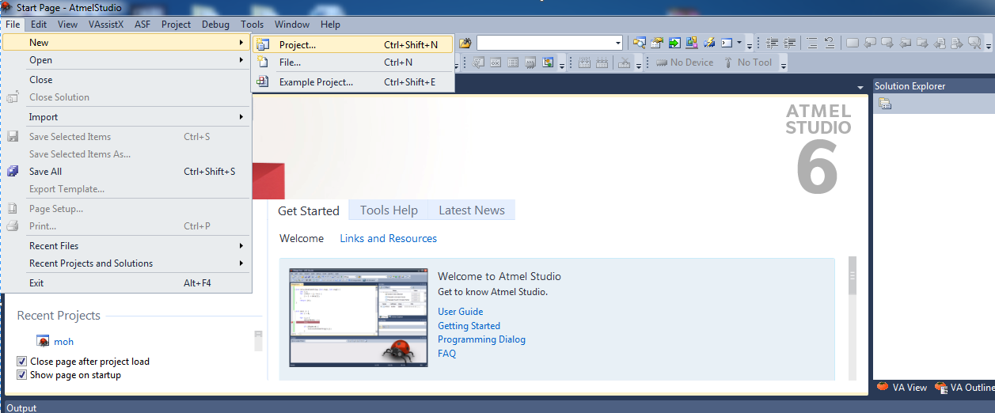  
you can click on (Ctrl + shift +N ) to make it simple and fast.

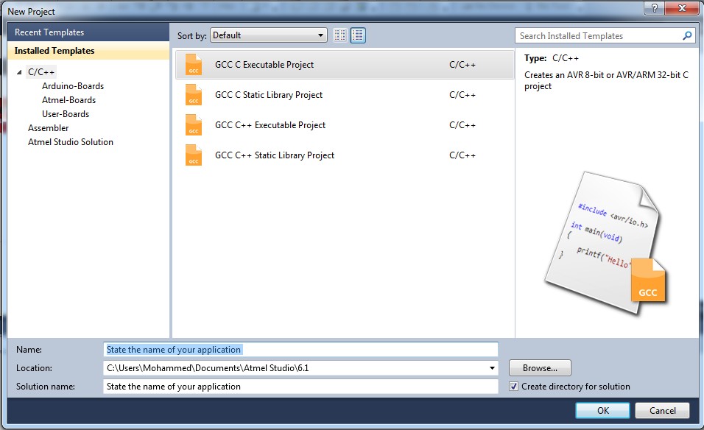

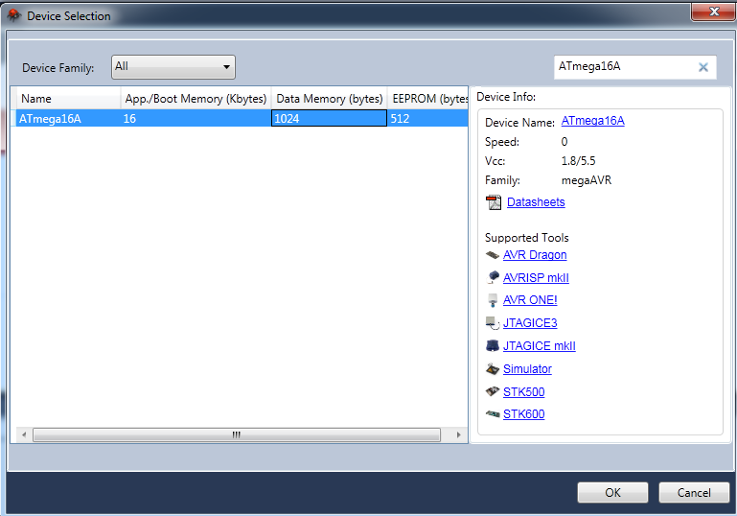

You can search online about your microcontroller from the available links which are given by Atmel Studio.

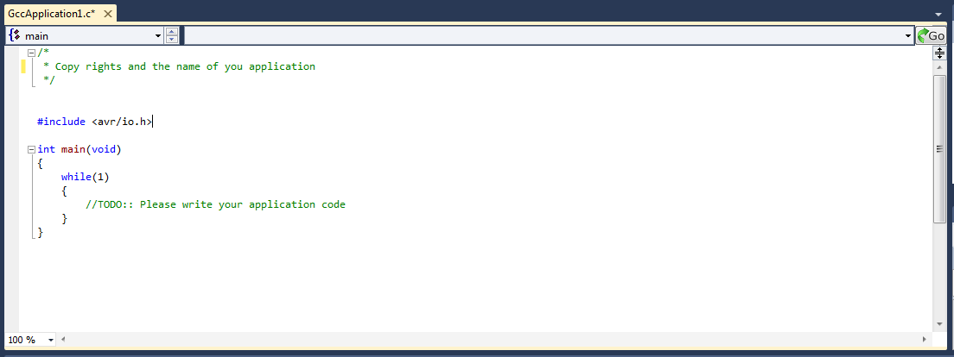

Write your code and compile it by **F7 (Build all).** After that, the ***hex file*** will be generated and the task now is to load or burn it into microcontroller by using USBASP.

*How to use **AVRDUDESS** to burn and load the **hex file** into micro controller.

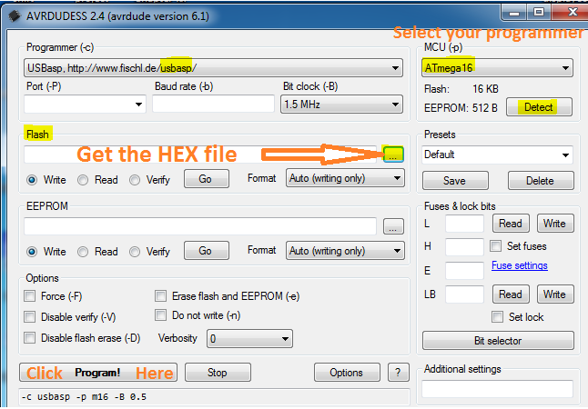

After choosing **usbasp** or any programmer, you have to select the microcontroller, or connect the hardware correctly and click detect to write your microcontroller.

You have to upload and get your **hex** file into the flash memory and click program. Then all will work properly.

**How to connect the hardware?**

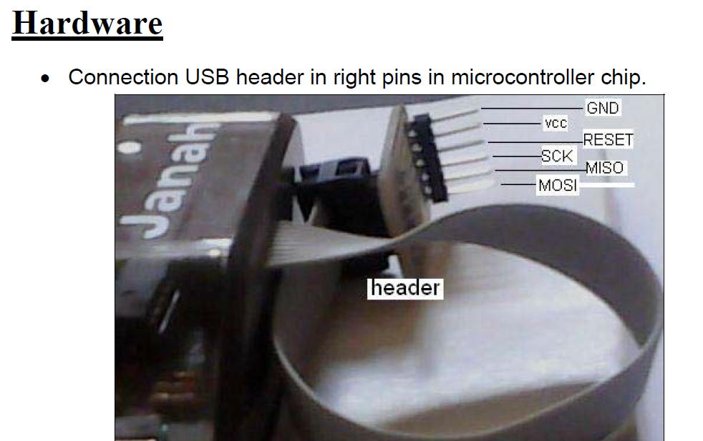

Select the same pins on the microcontroller.

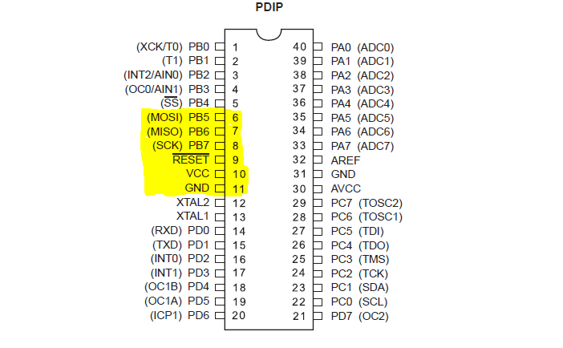

**For importance:**

**1- You have to setup and configure your *Usbasp* programmer. You can download from this link ((**[**Click Here**](http://www.fischl.de/usbasp/)**)).**

**2- You have to setup AVRDUDESS. . You can download from this link (**[**Here**](http://blog.zakkemble.co.uk/avrdudess-a-gui-for-avrdude/)**).**

**3- You can directly burn from the GUI of Atmel Studio By doing these steps:**

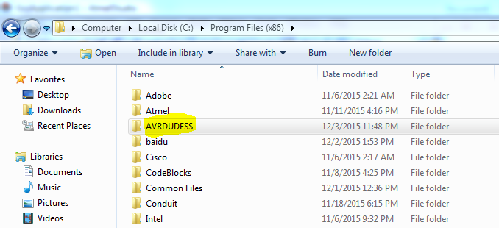

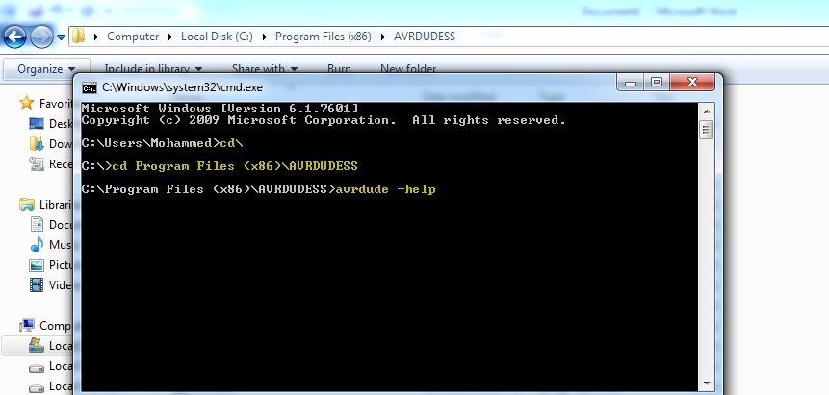

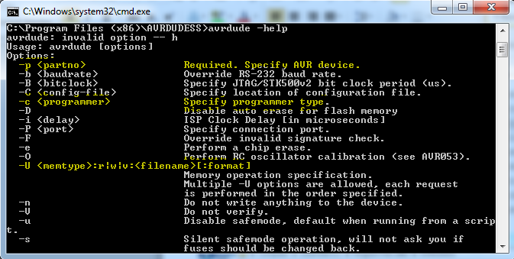

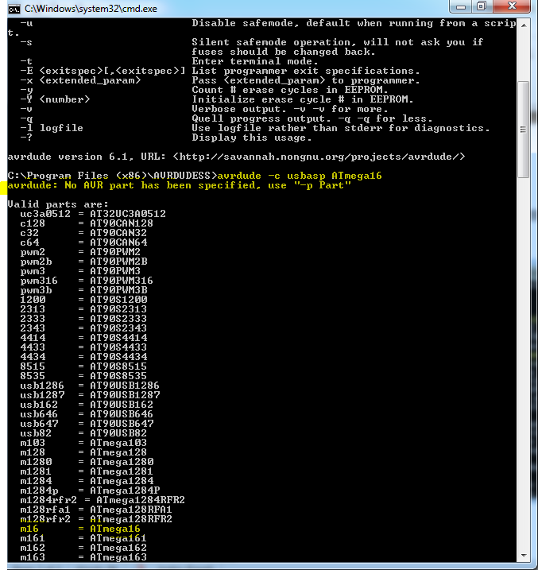

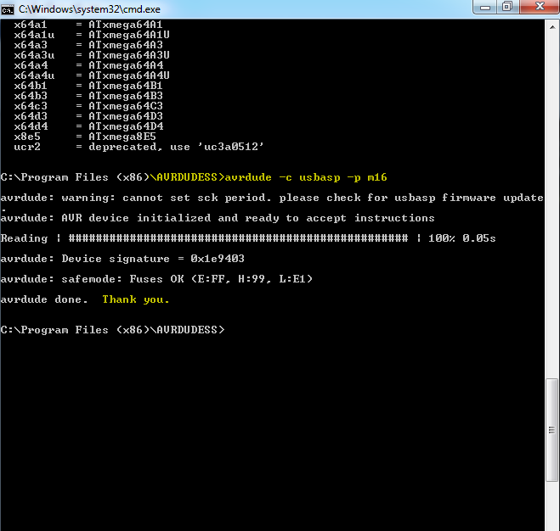

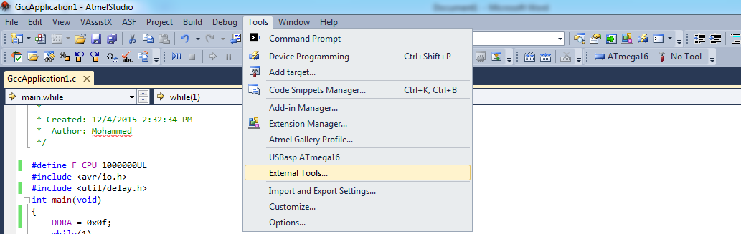

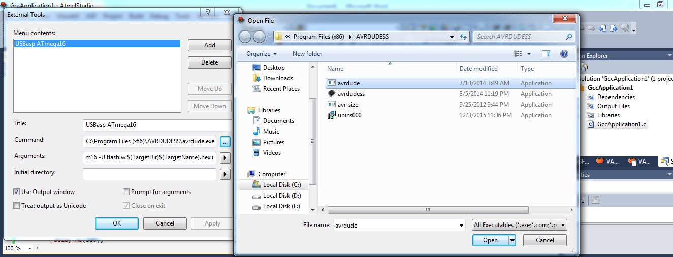

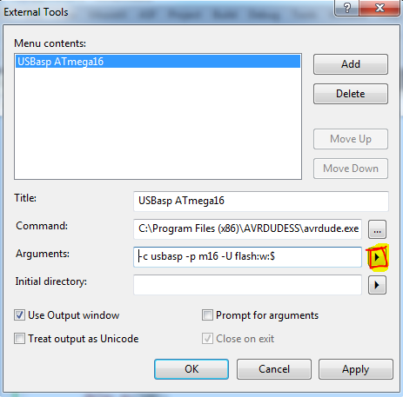

**You will choose *target directory* after that *target name* and write. hex:i for Conversion into hex file.**

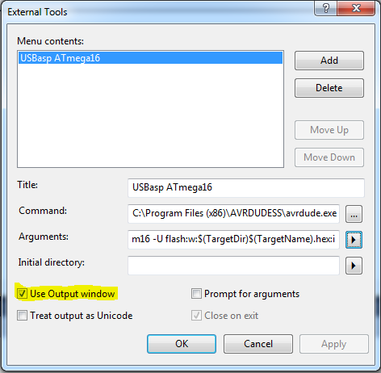

The previous highlighted text is to show the output on Atmel Studio without using **CMD**.

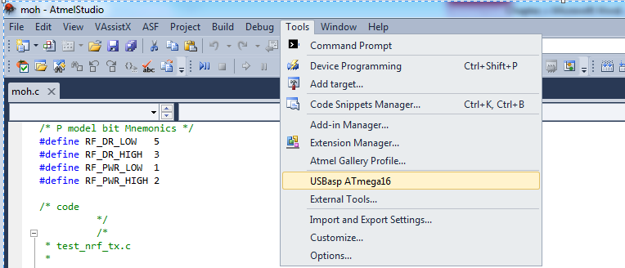

**Our project Hardware:**

**A- Batteries and battery charger:**

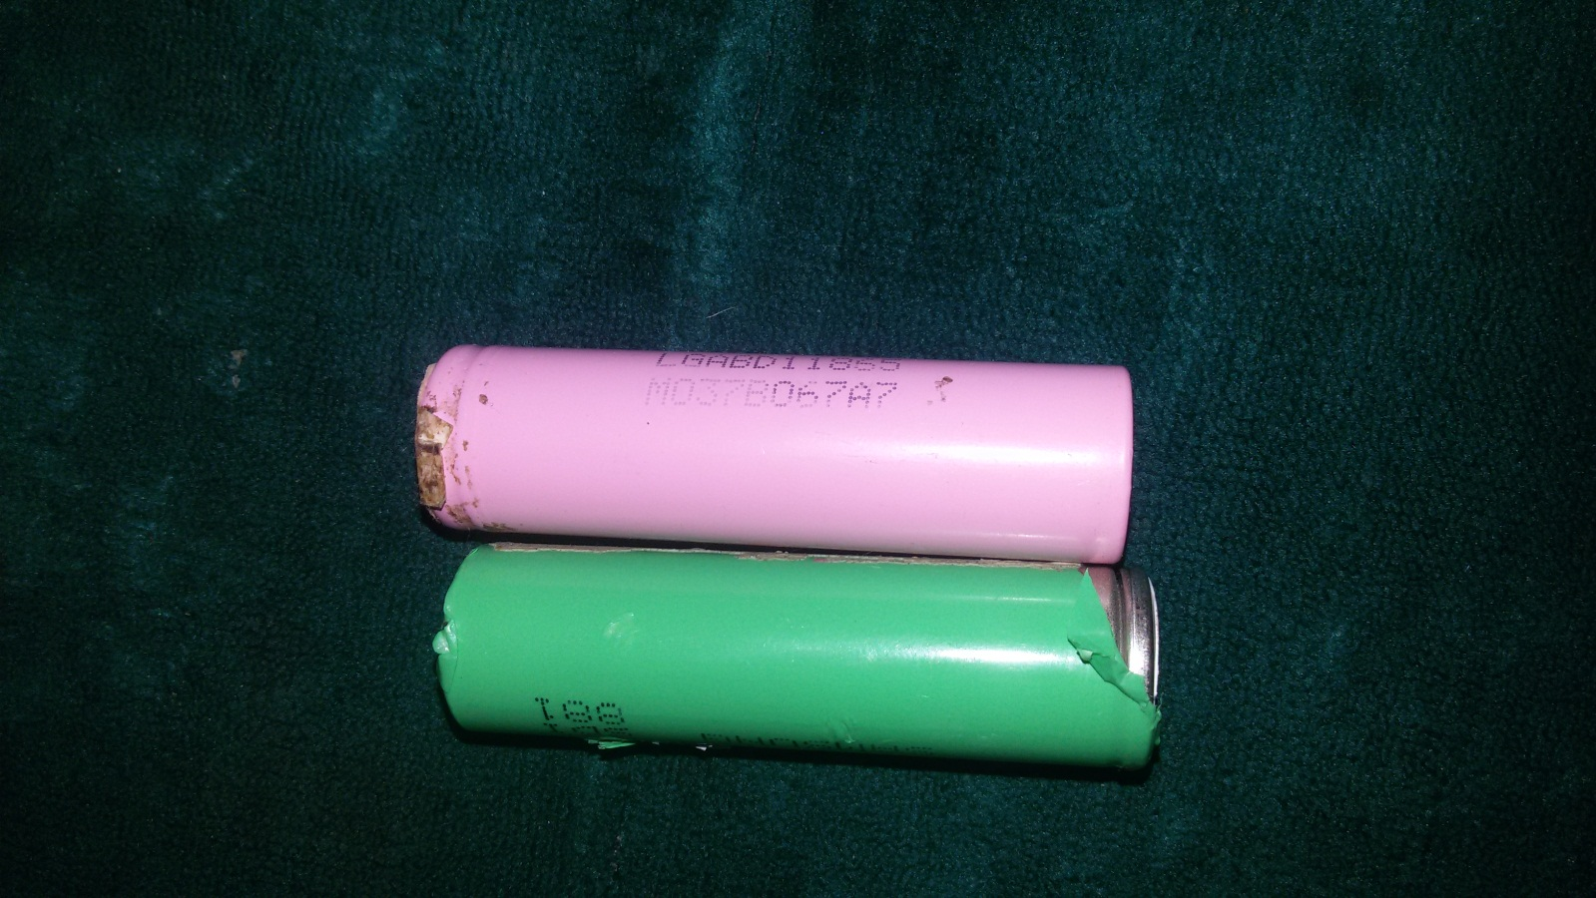

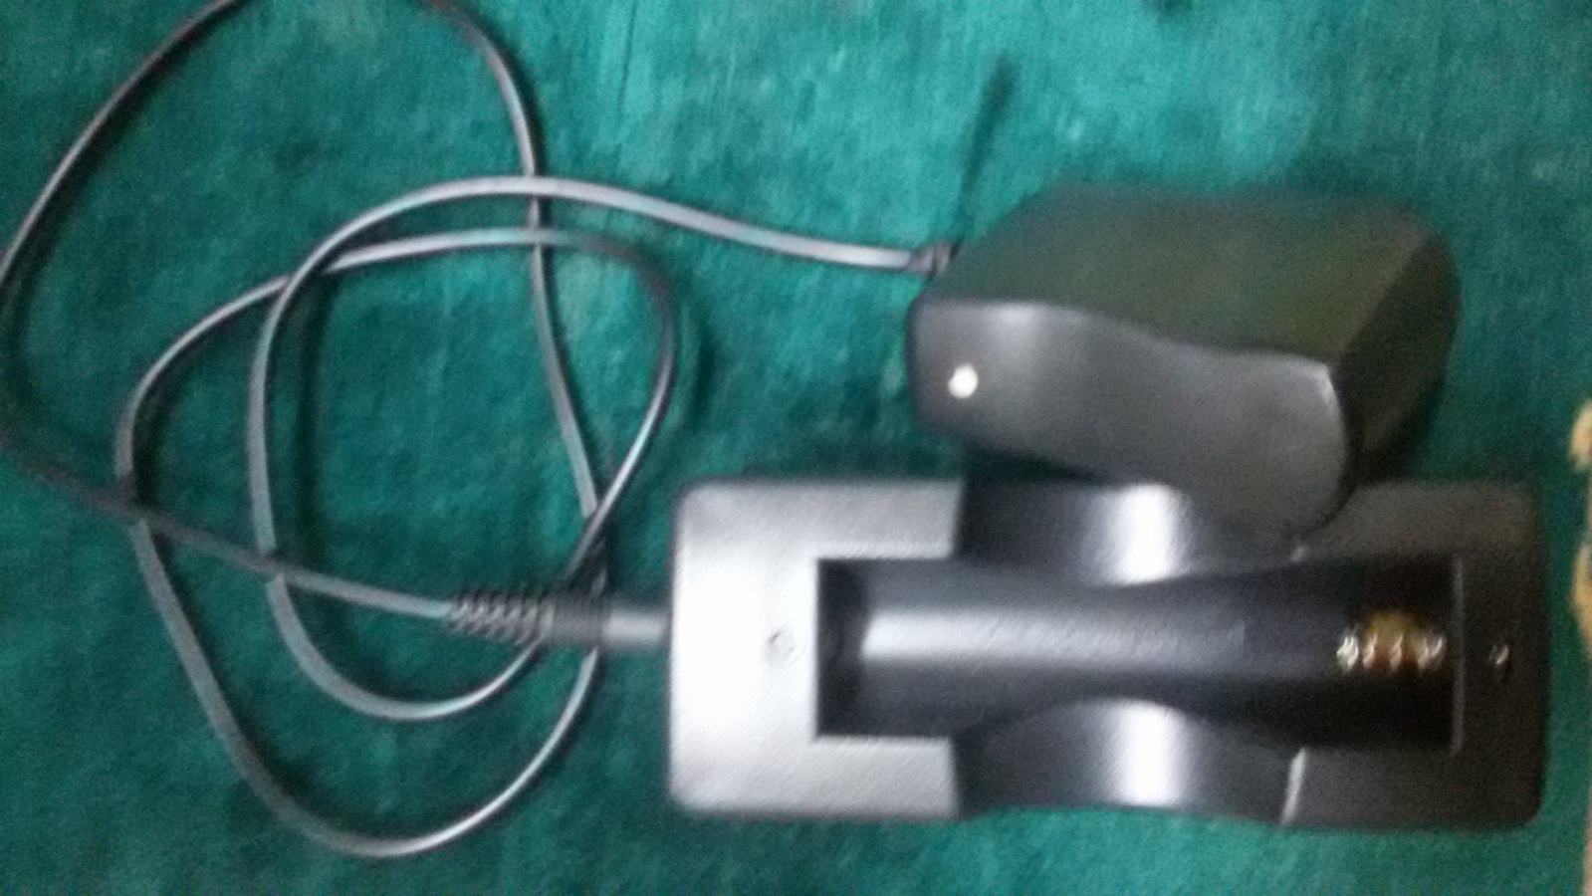

**B- Transmitter circuit:**

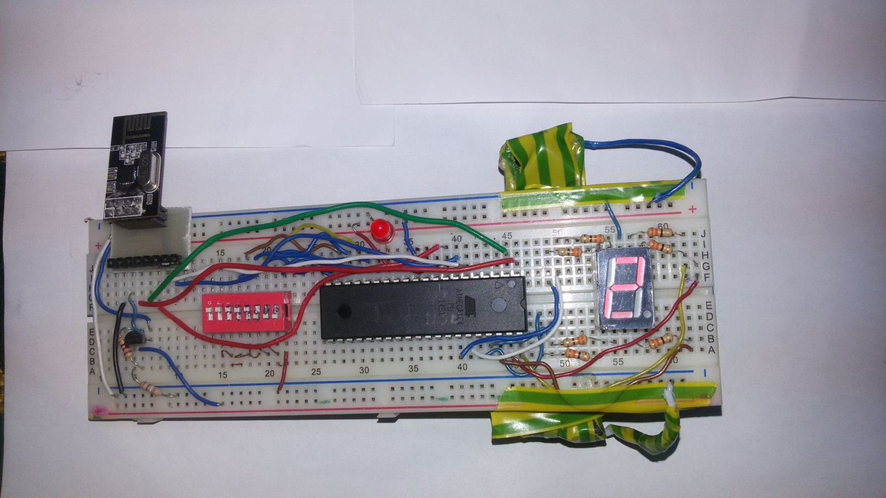

**C- First receiver circuit:**

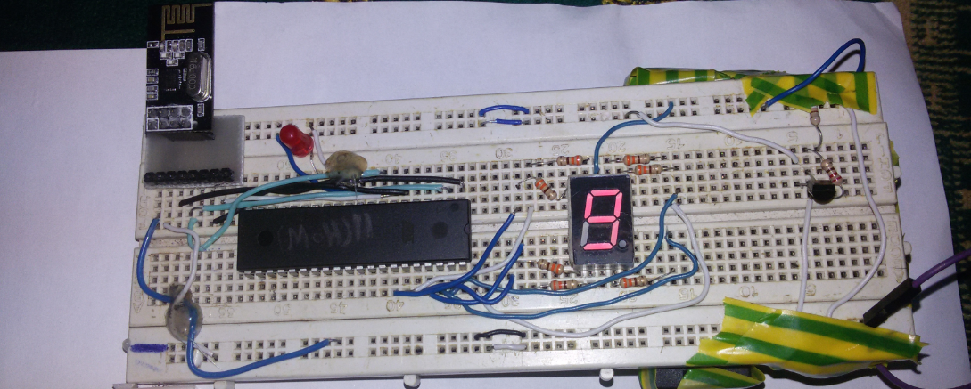

**D- Second receiver circuit:**

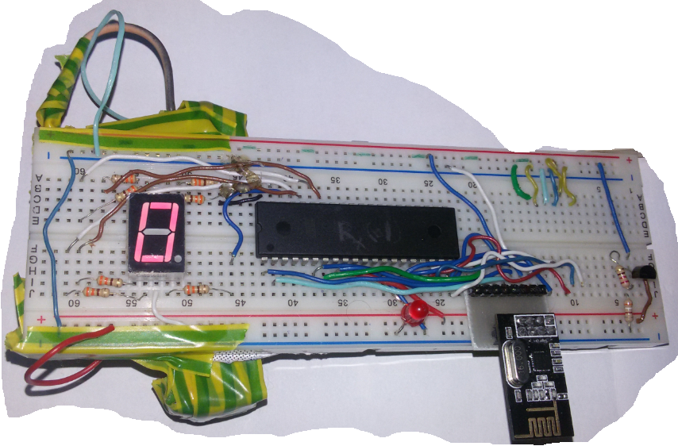

**All circuits when communicating:**

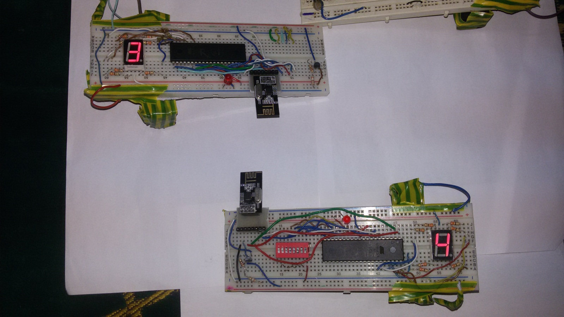

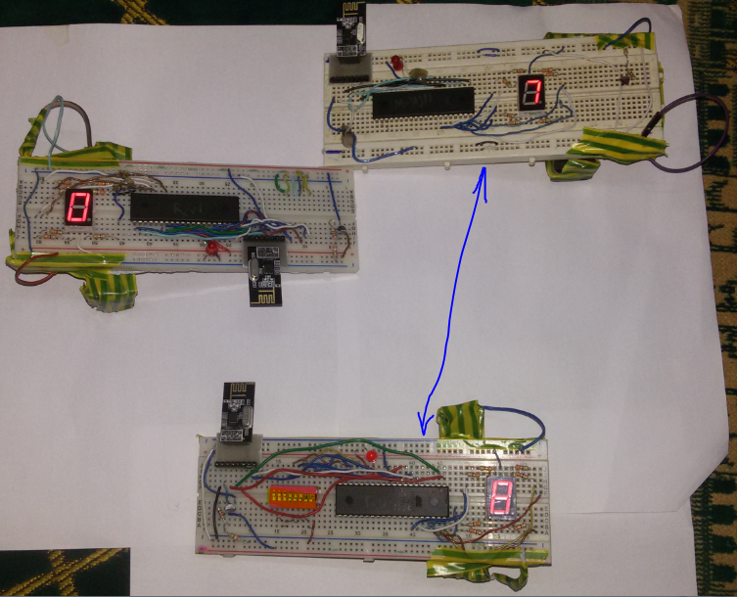

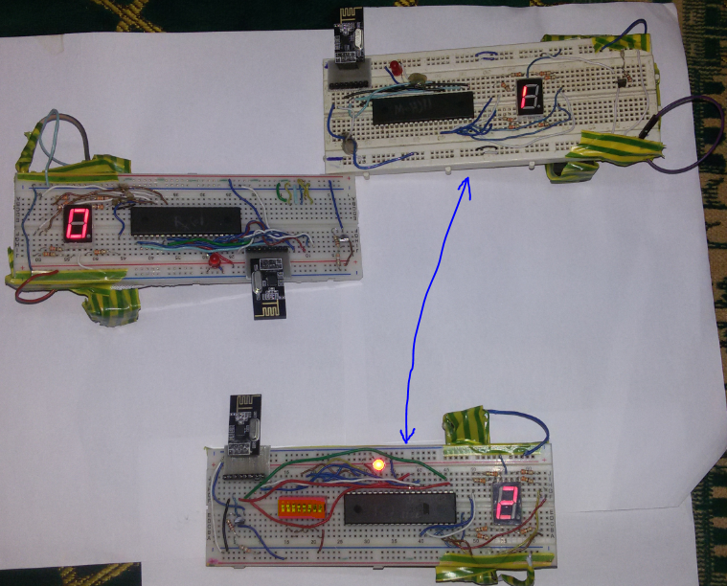

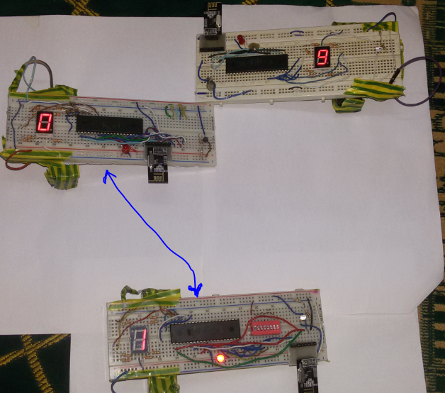

**Simple Application:**

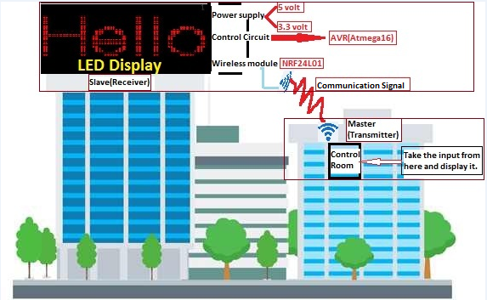

We can use our project to control LED Display Texts wireless without using computer interface. So, we can use one transmitter and a lot numbers of slaves connected to LED Displays to show what I want.

***Future Scope:***

1- Using light sensor to control LED display illumination.

2- Getting the high reliability of NRF24l01 to make an effective communication.

3- Interfacing keypads to change the display show manually.